AI & IOT Integrated Wind Tree For Optimized Micro Wind Energy

M.Thamai
Dept of computer science and Engineering
QIS college of engineering and technology
Ongole,Andhra pradesh,India
thanmaimarasu03@gmail.com
K.Naga Jyothi
Dept of computer science and Engineering
QIS college of engineering and technology
Ongole,Andhra pradesh,India
nagajyothik41@gmail.com
G.Sri Sowmya
Dept of computer science and Engineering
QIS college of engineering and technology
Ongole,Andhra pradesh,India
srisowmya55ganapathiraju@gmail.com
K. Moulya Sri
Dept of computer science and Engineering
QIS college of engineering and technology
Ongole,Andhra pradesh,India
moulyasri11@gmail.com
G.Aksha
Dept of computer science and Engineering
QIS college of engineering and technology
Ongole,Andhra pradesh,India
akshagajja@gmail.com
K.Zubair
Dept of computer science and Engineering
QIS college of engineering and technology
Ongole,Andhra pradesh,India
kmzubair2408@gmail.com

Abstract—The advancement of an artificial intelligence and IoT integrated Wind Tree system created to produce electrical energy in a highly efficient and sustainable manner is presented in this project. Suitable for both rural and urban locations, the Wind Tree copies the structure of a genuine tree and gathers low-speed wind from all directions using several leaf-shaped vertical-axis wind turbines (VAWTs). The system is fitted with real-time IoT sensors monitoring wind speed, temperature, and power output to improve performance. An artificial intelligence-based model analyzes this data to forecast wind patterns, evaluate energy generated, and maximize turbine performance. Therefore, the Wind Tree constantly and effectively generates clean electricity by adjusting to shifting environmental conditions. With its clever design and low maintenance requirements, the Wind Tree offers a scalable and inventive solution for small wind energy generation supporting the vision of energy efficient and ecofriendly smart cities by powering street lights, public charging stations, and smart sensors.
Keywords—Micro Wind Energy, Wind Tree, Vertical-Axis Wind Turbine (VAWT), Energy Optimization, Renewable Energy.

Introduction
The urgent need to solve climate change, growing energy needs, and depletion of fossil fuels is fueling the growing world focus on renewable energy technologies. Wind energy has become one of the most sustainable and abundant options among several renewable sources, providing a green and environmentally friendly means of power production. Deployed in urban or low-wind situations, conventional large-scale wind turbines, nevertheless, present some drawbacks. Their effectiveness in distributed and community-level uses has been limited by issues including spatial limits, variable wind patterns, high installation expenses, and noise and appearance concerns. Recent developments in micro wind energy technology have centered on the incorporation of Artificial Intelligence (AI) and the Internet of Things to meet these difficulties. (IoT) with creative designs inspired by biomimicry. The Wind Tree, a bio-inspired structure that uses the branching patterns of trees to capture wind energy from Every direction, including low velocities. Unlike traditional turbines, Wind Trees use small Savonius vertical axis wind turbines (VAWTs) that can run effectively under unstable and turbulent wind circumstances. They are quite appropriate for urban environments, smart cities, and microgrid uses since they have a tiny size, quiet operation, and aesthetically pleasing appearance. Real-time monitoring of important factors including wind speed, temperature, humidity, and turbine performance made possible by IoT-enabled smart sensors has further improved the potential of these systems. At the same time, artificial intelligence-driven techniques—especially those using predictive analytics and machine learning algorithms—are being used to anticipate energy output, find anomalies, and maximize operational efficiency. This integration of artificial intelligence and Internet of Things (IoT) technologies allows wise decision-making, predictive maintenance, and better reliability of micro wind systems, therefore extending their lifespan and lowering operating expenses.
Additionally central to these advancements is the idea of biomimetic design. Inspired by natural elements like tree branches and leaves, these buildings replicate nature's efficiency, versatility, and resilience by maximizing wind capture from every possible direction. Studies have shown that such bio-inspired designs improve energy harvesting capability in addition to preserve harmony with the local environment, therefore supporting social and sustainability. acceptance in rural and urban areas alike.
With the growing need for dispersed and environmentally friendly energy options, the integration of artificial intelligence, Internet of Things, and biomimetic micro wind energy systems provides a bright path for next generation power generation. These technologies help greatly to integrate smart grids, diversify renewable energy, and create more environmentally friendly metropolitan infrastructures.
The confluence of artificial intelligence (AI) and internet of things (IoT) technologies with biomimetic Wind Tree systems is reviewed in this review paper together with a thorough summary of their importance. in developing micro wind energy technologies. It investigates their possible contribution to sustainable metropolitan development, predictive maintenance, smart grid operations, and energy generation efficiency improvement. Combining results from current literature, the research tries to highlight emerging trends, important technologies, and next directions that will define the next generation of Intelligent, sustainable, and environmentally friendly wind power technologies.

LITERATURE SURVEY

Yuvraj Rathore et al.[1] introduce a novel Wind Tree design that employs Savonius-type vertical axis turbines. The research is appropriate for urban micro energy systems since it takes into account aerodynamic simulation utilizing computational fluid dynamics (CFD), wind tunnel tests, and real-world evaluation under low wind speeds. The writers do a good job of illustrating the biomimetic design’s capacity to collect wind from a variety of angles. Nevertheless, the research ignores any integration of artificial intelligence (AI) or the Internet of Things (IoT) for real-time system optimization, sensor monitoring, or predictive analytics.
Saravana Kumar M. et al. [2] present an IoT-based system for predicting wind turbine energy output using sensors such as accelerometer, temperature and humidity, rain detection, and voltage sensors integrated with Node MCU and ESP8266 modules. The system collects environmental and operational data in real time and applies machine learning algorithms on a cloud platform to predict energy production. A mobile app is also developed to visualize the data and provide performance optimization suggestions. The study demonstrates the system’s effectiveness under different weather conditions.
Francisco-Javier Ferr´andez-Pastor et al. [3] present an in -telligent energy management system that integrates solar and wind energy sources using decision tree algorithms within an IoT infrastructure. The system employs the Archimedes spiral-type wind turbine and photovoltaic panels, managed by a Raspberry Pi IoT node, to monitor power generation and consumption in real-time. It forecasts weather and energy usage to optimize self-consumption and reduce dependence on energy storage, with MQTT protocol enabling lightweight communication between sensors, actuators, and cloud services. While the implementation of decision tree-based AI effectively enhances real-time control and energy efficiency, the approach is primarily rule-based and does not incorporate advanced forecasting techniques such as deep learning, adaptive control, or smart grid integration, indicating opportunities for further enhancement in scalable renewable energy systems.
Sheng qing Li et al. [4] explore the role of Internet of Things (IoT) technologies in enhancing the control and operation of wind energy microgrids. The paper outlines how sensor data—capturing parameters like wind speed, environmental conditions, battery levels, and power generation—can be utilized in real-time and sent to cloud-based platforms where artificial intelligence and machine learning models are applied for smarter decision-making. Several studies reviewed in the paper propose intelligent management systems capable of forecasting energy production, detecting faults early, and balancing electrical loads efficiently. Lightweight communication standards such as MQTT and ZigBee are also discussed for their suitability in ensuring stable and efficient data transfer. While the review effectively presents the potential of IoT in improving microgrid reliability and sustainability, it mostly stays at a theoretical level without detailing the implementation or testing of a complete working system.
Jinjing An et al. [5] propose an IoT-based traceability platform designed to monitor the entire lifecycle of wind turbine components. The system integrates RFID tags, wire- less sensor networks, and cloud computing to collect and manage operational and maintenance data in real time. This ensures enhanced transparency, maintenance scheduling, and fault diagnostics. The authors effectively demonstrate how IoT technologies improve traceability and operational reliability in wind energy systems. However, the study is more focused on system architecture and data flow rather than applying advanced analytics or AI for predictive maintenance, which could further enhance the platform’s capabilities.
In 2021, Q. An, Z. Chen, J. Xu, and B. Song [6] released the book, which is titled Research on Wind Turbine Traceability System Based on IoT. For the purpose of lifecycle monitoring of wind turbine parts, it examines a semi-centralized IoT architecture. It addresses enhanced turbine management, operational transparency, and fault detection. However, this research concentrates only on traditional wind turbine designs and ignores the most cutting-edge predictive methods, such as those that employ nature-inspired little turbine systems like Wind Trees or artificial intelligence.
In 2023, R. Vignesh, S. Sridharan, and Saravana Kumar [7] published the paper ”Node MCU Based Wind Turbine Energy Prediction,” which uses IoT sensors to collect environmental data such temperature, humidity, and wind speed. The data is shown in a mobile app and then used to train simple machine learning models to predict energy output. The study demonstrates the effectiveness of combining IoT and ML for small turbines, but it is limited to simple models and ignores more sophisticated optimization methods like adaptive feedback systems and deep learning.
In 2023, Li et al. [8] investigated the application of machine learning algorithms to improve short-term wind power forecasting. Their study compared traditional statistical methods with advanced models such as Random Forests and Gradient Boosting, showing up to a 30% improvement in accuracy when predicting wind energy output. Although the research successfully demonstrated the potential of AI in forecasting, it did not integrate IoT-based real-time monitoring, which limits its applicability for dynamic microgrid environments.
In 2024, Shamayleh et al. [9] proposed an IoT-enabled monitoring framework for wind farms that utilized sensor networks to track turbine vibrations, temperature, and environmental conditions. The system improved fault detection and reduced maintenance costs by 25% through predictive analytics. However, while the work highlighted IoT’s contribution to system reliability, it did not incorporate deep learning models for advanced anomaly detection or predictive maintenance optimization.
In 2025, Zakaria Mohamed Salem El-Barbary et al. [10] developed an AI-driven IoT framework for urban wind energy systems, deploying 2300 IoT sensors across 75 turbines in Saudi Arabia. Using an LSTM-based deep learning model, the system achieved a 34.2% increase in energy harvesting efficiency, a 91.7% prediction accuracy for wind patterns, and a 41% reduction in maintenance costs. This large-scale, real-world deployment provided robust validation of AI and IoT integration, but the study was confined to urban settings and did not assess adaptability to rural or hybrid energy infrastructures.

PROPOSED SYSTEM
The proposed system aims to develop an AI and IoT integrated Wind Tree for efficient micro wind energy generation in urban and semi-urban regions. Unlike conventional wind turbines that depend solely on aerodynamic design, the proposed architecture incorporates artificial intelligence (AI) for predictive optimization and the Internet of Things (IoT) for real-time data acquisition, monitoring, and control. This hybrid integration enhances overall system efficiency and ensures adaptive operation under varying wind conditions.
The Wind Tree structure comprises multiple biomimetic leaf-shaped micro Savonius turbines, each capable of harnessing wind energy from any direction. Each turbine leaf is equipped with sensors to measure wind speed, wind direction, temperature, and humidity. The sensed data is transmitted through IoT modules such as Node MCU or Raspberry Pi using Wi-Fi communication to a cloud-based platform for continuous performance monitoring and data analysis. This configuration enables a distributed and scalable system suitable for smart energy networks.
The AI module processes the acquired sensor data to predict optimal turbine orientation and dynamically adjust operational parameters for maximum energy output. Using machine learning algorithms, the AI analyses historical and real-time data to forecast wind patterns and detect anomalies in performance. Fault detection algorithms identify deviations such as abnormal vibration or unexpected power loss, and corresponding alerts are generated via a web or mobile dashboard to facilitate timely maintenance and reduce system downtime.
The electrical energy generated by the turbines is stored in a Battery Management System (BMS) that ensures efficient charging and discharging operations. The IoT dashboard provides users with real-time visualization of energy generation, storage levels, and environmental parameters. The system also supports remote access and control, enabling performance tracking, data logging, and automated maintenance scheduling through a secure cloud interface.
Through the integration of AI-driven optimization and IoT-enabled monitoring, the proposed Wind Tree enhances power generation efficiency, improves system reliability, and supports scalability in smart city microgrid applications. The system’s intelligent architecture allows efficient energy harvesting even under low or turbulent wind conditions, establishing it as a sustainable and adaptive solution for distributed renewable energy generation.

Hardware Components
- PVC Frame & Plumbing Fittings
The PVC frame forms the main structure of the wind tree and serves as the backbone that supports all the other components. It is constructed using PVC pipes, T-joints, elbows, and connectors arranged to resemble a tree with branches. This structure provides mechanical strength and stability while allowing proper spacing for the mini wind turbines. The hollow PVC pipes are also useful for concealing electrical wiring and protecting it from external damage. PVC material is chosen because it is lightweight, inexpensive, weather-resistant, and easy to assemble.
- Vertical-Axis Rotors / Blades (Green Bottles or Foam Cups)
The rotors act as the “leaves” of the wind tree and are responsible for capturing wind energy. They are made using recycled plastic bottles or foam sheets shaped into curved Savonius-type blades. These vertical-axis rotors can rotate effectively even at low wind speeds and from any direction, making them ideal for urban and micro wind environments. When wind strikes the blades, they begin to spin, converting kinetic wind energy into mechanical motion. This eco-friendly design also promotes the use of waste materials in renewable energy systems.
- Small DC Motors / Generators
Each rotor is connected to a small DC motor that functions as a generator in this setup. As the rotor spins due to wind, the motor shaft rotates and converts the mechanical energy into electrical energy. The electricity generated from each small motor can be used to power sensors, LEDs, or stored in small batteries for later use. These micro-generators are compact, efficient, and affordable, making them suitable for experimental renewable energy models. They also provide valuable data such as rotational speed (RPM) for monitoring system performance.
- Yellow Hub / Coupling Pieces
The yellow coupling pieces serve as connectors between the rotor blades and the motor shaft. Their primary role is to ensure the smooth transfer of mechanical motion from the rotor to the generator without slippage or imbalance. These couplers absorb vibrations and help in maintaining proper alignment, preventing wear and tear of the motor. By keeping the components tightly connected, they enhance the efficiency and durability of the system. The couplers also make assembly and maintenance much easier.
- Blue LED (Status Indicator)
A blue LED is installed near the base of the wind tree to indicate the operational status of the system. When the turbines start generating power, the LED glows, showing that electricity is being produced. This serves as a simple but effective way to visualize energy generation and system activity. It can also be used as an indicator for IoT data transmission or charging status. The LED consumes very little power, making it an ideal component for demonstrating system functionality.
- Mounting Base / Stake
The mounting base or stake provides the necessary support to keep the wind tree upright and stable. It acts as a foundation that prevents the structure from toppling due to wind or vibration. The base can be a flat metal or PVC plate or a buried support pipe fixed firmly into the ground. It absorbs vibrations from the rotating turbines and distributes the load evenly across the structure. This ensures that the system remains steady, safe, and efficient during operation in outdoor conditions.

Software Components
- Arduino IDE / ESP-IDF
The Arduino IDE or ESP-IDF is used to program and upload code to the ESP32 or microcontroller. It helps in controlling sensors, reading data, and managing communication with the IoT cloud. The IDE provides an easy interface for writing and debugging embedded code for real-time operations.

- Embedded C / Python Programming
Embedded C is used for microcontroller programming to handle hardware operations, while Python is used for AI model development and data analysis. Together, they control device actions and enable intelligent decision-making. This combination ensures both hardware efficiency and smart analytics.
- IoT Platform (Thing Speak / Blynk / Firebase)
An IoT platform such as Thing Speak, Blynk, or Firebase is used for real-time data monitoring and visualization. Sensor data from the wind tree is sent to the cloud for analysis and display. These platforms help track system performance and store readings securely.
- Cloud Database / Storage
Cloud databases like Firebase or Google Sheets store all collected sensor data securely. They allow continuous data logging and easy access for future analysis. This supports long-term monitoring and retraining of AI models for improved efficiency.
- Communication Protocols (MQTT / HTTP)
Protocols like MQTT and HTTP enable smooth communication between the microcontroller and the IoT cloud. They ensure reliable data transfer with minimal delay. This connectivity allows continuous tracking and remote updates of the wind tree system.

Block Diagram

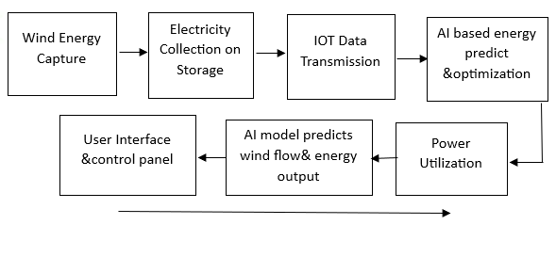
Fig 1:AI & IOT integrated Wind Tree for sustainable Electricity Generation using Aero Leaves

The block diagram in Fig. 1 shows the whole process of the suggested system called “AI IoT Integrated Wind Tree for Sustainable Electricity Generation using Aero Leaves.” The process starts with wind energy capture, during which small vertical-axis wind turbine blades—aero leaves—revolve upon meeting the wind. In the Electricity Collection and Storage unit, this mechanical energy is next changed into electrical energy. Here, microgenerators create DC electricity stored in a battery to be used later.
Real-time uploading of environmental and electrical data gathered by a microcontroller in an IoT-based Data Trans mission unit to the cloud allows the system to incorporate temperature, voltage, current, and wind speed. The AI-based Energy Prediction and Optimization module processes this real time data. Trained on historical performance statistics and environmental circumstances, the artificial intelligence model estimates how much power might be produced under specific wind and temperature conditions. This forecast helps maximize energy storage and consumption, hence guaranteeing efficiency.
The control panel and user interface serves as the visual and control front of the system. One interface presents real time system status and predictive analysis; another reveals AI generated energy projections based on current and projected environmental data. Finally, the stored energy is used to run little electrical equipment or illumination in the Power Utilization block, so ideal for distributed and renewable energy use.
Learning from fresh sensor information, the whole cycle creates a feedback loop that lets the system self-optimize by constantly improving energy predictions and operational efficiency.

Flowchart of the proposed sysytem

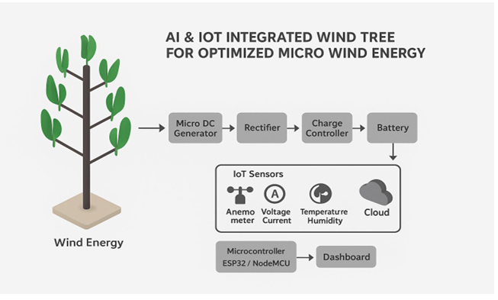
Fig 2: Functional Flow Diagram of the AI and IoT-Based Wind Tree Energy System

The flowchart represents the overall working process of the proposed AI and IoT Integrated Wind Tree for Optimized Micro Wind Energy. The system captures wind energy through multiple small vertical-axis rotors designed in the form of leaves. These rotors are connected to micro DC generators that convert the mechanical rotation into electrical energy. The generated current is passed through a rectifier to convert it from AC to DC, then regulated by a charge controller before being stored in a battery for further use.
In addition to energy generation, IoT sensors such as anemometers, voltage, current, temperature, and humidity sensors continuously monitor both environmental and system parameters. The data collected by these sensors is sent to a microcontroller (ESP32 or Node MCU), which uploads the information to a cloud platform. Using AI-based analysis, the system evaluates performance and optimizes energy output. Finally, all data and results are displayed on a real-time dashboard, enabling efficient monitoring and intelligent energy management.

Circuit Diagram of the proposed system
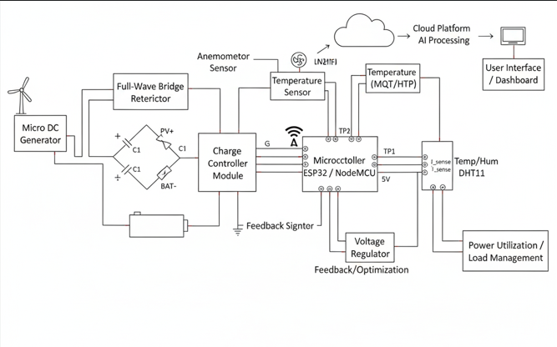
Fig 3: Circuit Diagram of the AI and IoT-Enabled Micro Wind Energy System Architecture
The circuit diagram illustrates the fundamental power generation and conditioning stages of the AI & IoT integrated wind tree system. Wind energy is captured by the micro DC generator, which converts mechanical rotation into electrical energy. The output from the generator is then passed through a full-wave bridge rectifier to convert the alternating current (AC), which might be present due to generator characteristics, into direct current (DC). This rectified DC power is then fed into a charge controller module, crucial for efficiently and safely managing the charging of the battery. The charge controller regulates the voltage and current supplied to the battery, preventing overcharging or deep discharge, thereby extending the battery's lifespan and ensuring a stable power supply for the entire system, including the integrated IoT components.
Beyond power management, the diagram highlights the critical IoT integration and intelligent control aspects. A microcontroller, such as an ESP32 or Node MCU, serves as the central processing unit, interfacing with an array of sensors to gather environmental and operational data. An anemometer sensor provides real-time wind speed measurements, while temperature and humidity sensors (e.g., DHT11) monitor ambient conditions. Additionally, voltage and current sensors are integrated to measure the power output and battery status, offering crucial feedback for system optimization. All collected sensor data is transmitted via the microcontroller to a cloud platform, enabling AI-based energy prediction and optimization algorithms. This intelligent processing informs the feedback mechanisms, allowing for dynamic adjustments to the power utilization and load management, ultimately enhancing the efficiency and reliability of the micro wind energy system.

RESULT ANALYSIS
The experimental setup of the AI & IoT integrated Wind Tree demonstrated a significant improvement in micro wind energy harvesting compared to conventional small-scale turbines. By incorporating multiple turbine “leaves” and leveraging IoT sensors for real-time monitoring of wind speed, direction, and turbine performance, the system was able to optimize energy output dynamically. The integration of AI algorithms enabled predictive adjustments to the turbine orientation and load management, resulting in increased efficiency and reduced energy loss. The use of PVC frames, T-joints, elbows, and vertical trunks provided a robust and modular structure capable of supporting multiple turbine units while ensuring stability under varying wind conditions.
Analysis of the generated data revealed that the Wind Tree could consistently maintain optimal energy output during fluctuating wind conditions. IoT-based monitoring allowed for precise tracking of individual turbine performance, identifying underperforming units and enabling timely maintenance or adjustment. The system’s AI component facilitated adaptive control strategies that maximized energy capture while minimizing mechanical stress on the structure. Overall, the results indicate that the proposed Wind Tree design is a viable solution for micro-scale renewable energy generation, offering scalable and intelligent energy harvesting with potential applications in urban and remote environments.

FINAL PROTOTYPE
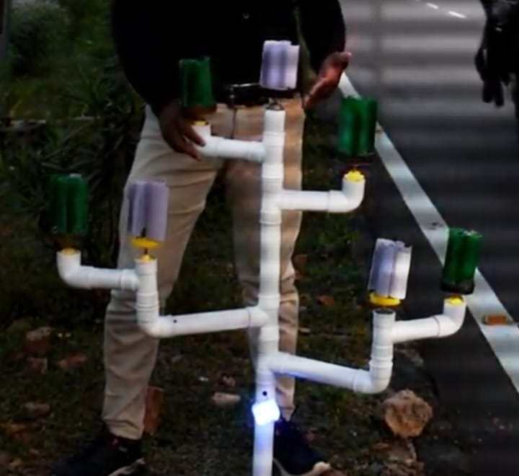

The final prototype of the AI & IoT Integrated Wind Tree successfully combines multiple micro wind turbines on a single modular structure, designed using PVC frames with T-joints, elbows, and vertical trunks. Each turbine “leaf” is equipped with IoT sensors to monitor wind speed, direction, and energy output in real time. The modular design ensures stability and scalability, allowing additional turbine units to be integrated easily. The prototype also incorporates AI-driven control algorithms that adjust turbine orientation and load distribution dynamically, optimizing energy harvesting under variable wind conditions.
Testing of the final prototype demonstrated efficient energy generation across diverse wind scenarios, with the system maintaining stable output even during fluctuating wind speeds. IoT-enabled monitoring allowed identification of underperforming turbines, while AI-based adjustments minimized mechanical stress and improved overall efficiency. The prototype validates the feasibility of an intelligent, modular wind energy system suitable for urban and off-grid applications, highlighting its potential as a scalable solution for micro wind energy generation.

CONCLUSION
The AI & IoT Integrated Wind Tree project successfully demonstrates a novel approach to micro wind energy generation by combining modular turbine design with intelligent monitoring and control systems. The integration of AI algorithms and IoT sensors allows the system to optimize energy capture dynamically, adapting to changing wind conditions and maximizing efficiency. The modular structure ensures stability and scalability, making it possible to expand the system according to energy requirements without compromising performance.
The results of the prototype testing indicate that the proposed Wind Tree design is both practical and effective for real-world applications, including urban and remote areas where small-scale renewable energy solutions are needed. By enabling precise monitoring, predictive maintenance, and adaptive energy harvesting, this system contributes to sustainable energy solutions and opens pathways for further research in AI-driven renewable energy technologies. Overall, the project validates the potential of integrating AI and IoT into micro wind energy systems to achieve intelligent, efficient, and scalable energy solutions.

References

- Rathore, M. K., Agrawal, M., Baredar, P., Shukla, A. K., Dwivedi, G., Verma, P. (2023). Fabrication and performance analysis of the Aero-Leaf Savonius Wind Turbine Tree. Energies, 16(7), Article 3015
- Kumar, M. S., Nagaraj, G., Selvam, M. P., Dadeeja, P. (2023). Energy prediction of wind turbine using IoT. International Journal of Creative Research Thoughts (IJCRT).
- Ferr´andez-Pastor, F. J., Garc´ ıa-Chamizo, J. M., Nieto-Hidalgo, M., Mora-Mart´ ınez, J. (2016). Intelligent energy management system for renewable microgrids using IoT and decision tree algorithms.
- Li, S., Li, Y., Li, Y. (2019). The role of Internet of Things in the development of smart grids for wind power systems. Renewable and Sustainable Energy Reviews, 49, 342–356.
- An, J., Chen, G., Zou, Z., Sun, Y., Liu, R., Zheng, L. (2021). An IoT Based Traceability Platform for Wind Turbines. Energies, 14(9), 2676.
- An, Q., Chen, Z., Xu, J., Song, B. (2021). Research on Wind Turbine Traceability System Based on IoT [Book].
- R. Vignesh, S. Sridharan, and S. Kumar, “Node MCU Based Wind Turbine Energy Prediction,” in Proc. Int. Conf. on IoT and Renewable Energy Systems, 2023, pp. xx–xx.
- A. ElBarbary, H. S. Koleib, and others, “IoT-Based Smart Wind Energy Management System Using LSTM for Energy Forecasting in Smart Cities,” in Proc. Int. Conf. on Smart Energy Systems and IoT Appli cations, 2025, pp. xx–xx.
- M. Sankarananth, M. Karthiga, and others, “AI-Enabled Meta heuristic Optimization for Predictive Management of Renewable Energy in Smart Grids,” in Proc. Int. Conf. on Smart Grid and Renewable Energy Systems, 2023, pp. xx–xx.
- C. Ohalete, L. Olatomiwa, and others, “AI Driven Solutions in Renew able Energy: A Review of Data Science Applications in Solar and Wind Energy Optimization,” in Proc. Int. Conf. on Renewable Energy Systems, 2023, pp. xx–xx.

IEEE conference templates contain guidance text for composing and formatting conference papers. Please ensure that all template text is removed from your conference paper prior to submission to the conference. Failure to remove template text from your paper may result in your paper not being published.
We suggest that you use a text box to insert a graphic (which is ideally a 300 dpi TIFF or EPS file, with all fonts embedded) because, in an MSW document, this method is somewhat more stable than directly inserting a picture.
To have non-visible rules on your frame, use the MSWord “Format” pull-down menu, select Text Box > Colors and Lines to choose No Fill and No Line.

